The Faculty of Creative and Cultural Industries comprises courses, research, enterprise and innovation activities concerned with the practice, analysis and criticism of the creative industries. Located primarily in the Eldon and White Swan Buildings of the University, the Faculty has over 3,400 students in its four academic departments:

- The Portsmouth School of Architecture

- The School of Art, Design and Performance

- The School of Film, Media and Communication

- The School of Creative Technologies

Our teaching is committed to the synthesis of the critical and practical skills, knowledge and understanding that make our graduates succeed as professionals within the broad range of the creative industries. Innovation is central to our disciplines and courses, and the faculty is committed to a range of material, visual and digital practices through which our students and staff learn and drive forward their disciplines. CCI is committed to the disciplinary specialism that enables collaborative inter-and trans-disciplinary practices to thrive and the faculty enjoys the collaborative opportunities that a large multidisciplinary institution offers as well as extensive partnership with the creative industries and sectors.

The University maintains a strategic commitment to ensuring that our courses are offered within a community of diverse and collaborative practices through which our students learn alongside and from one another. To this end, our students learn in dedicated studio environments, technical facilities and workshops, and we maintain a rigorous commitment to analogue and digital technologies. We aim to create an open and collaborative environment to foster a culture of experiment and innovation and ensure that all students establish the broadest possible experience and expertise. Central to this is the recognition at the heart of our courses that students must be supported into independent critical practice and creativity. As such, students are offered a breadth of technical education with increasing and staged specialisation throughout the course of their study.

The Eldon Production Centre includes traditional wood, plastic and metal workshop facilities and contemporary production technologies such as laser cutting, fabric printing and 3D printing. Courses share a number of disciplinary specialist workshops and facilities including a sewing workshop, analogue and digital photography darkrooms and studio, screen-printing, letterpress and sublimation and digital fabric printing. Our extensive digital studios include over 600 open access Macs and PCs running a range of specialist industry-standard software. These are supported by specialist digital and creative technology facilities such as a Motion Capture Suite, Virtual Reality Lab, and Music and Sound Recording Studios. In addition, our campuses boast a number of TV and Film Studios and an extensive loans store of cameras and shootings kits.

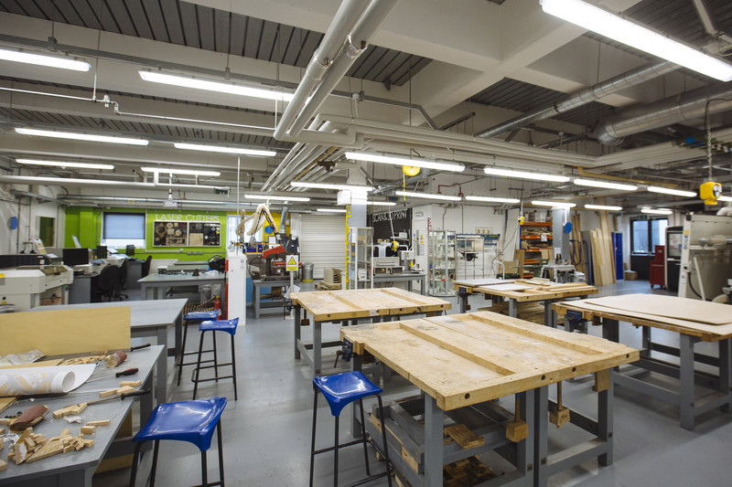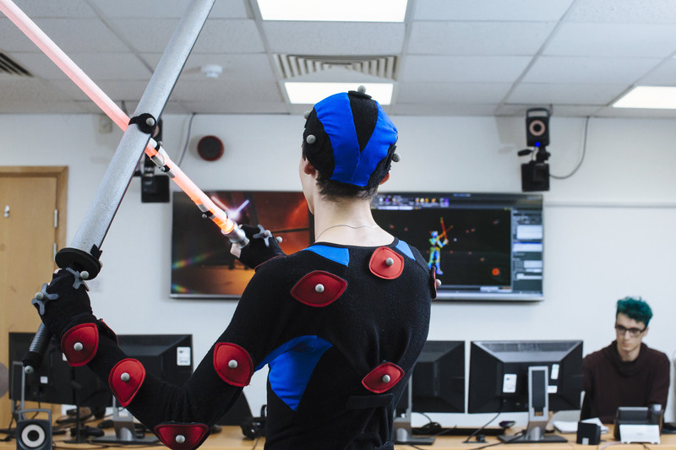

The White Swan Building is a dedicated performing arts space. Built as an extension to the New Theatre Royal, the building includes a number of rehearsal facilities furnished with sprung floors, lighting and mirrors, a sound recording studio, video editing suite, TV Studio and music practice rooms. The building includes a purpose-built double height studio theatre. With a raked-seating capacity of 100 and housing a full lighting rig and technical gallery, this professional workspace is regularly used by students to present their work.

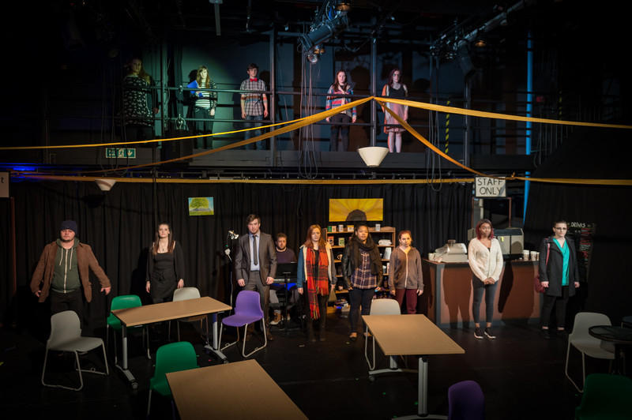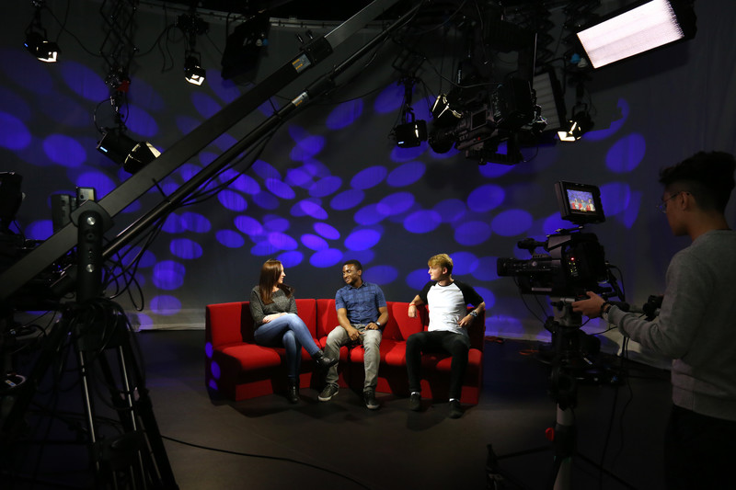

The School of Creative Technologies is a well-established and very successful school in the Faculty. The school comprises 900 students and 35 members of academic staff, and has recently been restructured to focus upon courses in computer games technology & enterprise, animation, computer animation and VFX, creative and digital media, and music and sound technologies. The school works closely with industry and has strong industrial alignment and professional accreditation of JAMES and TIGA.

Staff and students in the School of Creative Technologies work with a range of technology companies including most recently IBM. Each year students undertake a range of ‘live’ project work in partnership with the Royal Navy, Ministry of Defence, and other companies. Most recently staff and students contributed to the highly successful inaugural Portsmouth Comic Con, International Festival of Comics, and celebrated its 10th annual Game Jam, with over 130 students, alumni and industry professionals coming together in teams to make games.

Staff are committed to further developing a culture of research and innovation, and contribute to the University of Portsmouth’s Future and Emerging Technologies Strategic Theme. The School has significant research excellence and expertise in the visual computing, virtual and augmented realities and digital heritage. Currently, a number of academic staff are working to support the University’s submission to RE2021 in the areas Computing, and Art and Design. Many are involved in externally funded collaborative projects and activities, and participate in national and international disciplinary networks.

Further details about the School and Faculty can be found at http://www.port.ac.uk/faculty-of-creative-and-cultural-industries/ and at http://creativespace.cci.port.ac.uk/ .

(Please note that we are currently transitioning to an entirely new University website that will reflect the realigned structure and activities of the Faculty and Schools).

