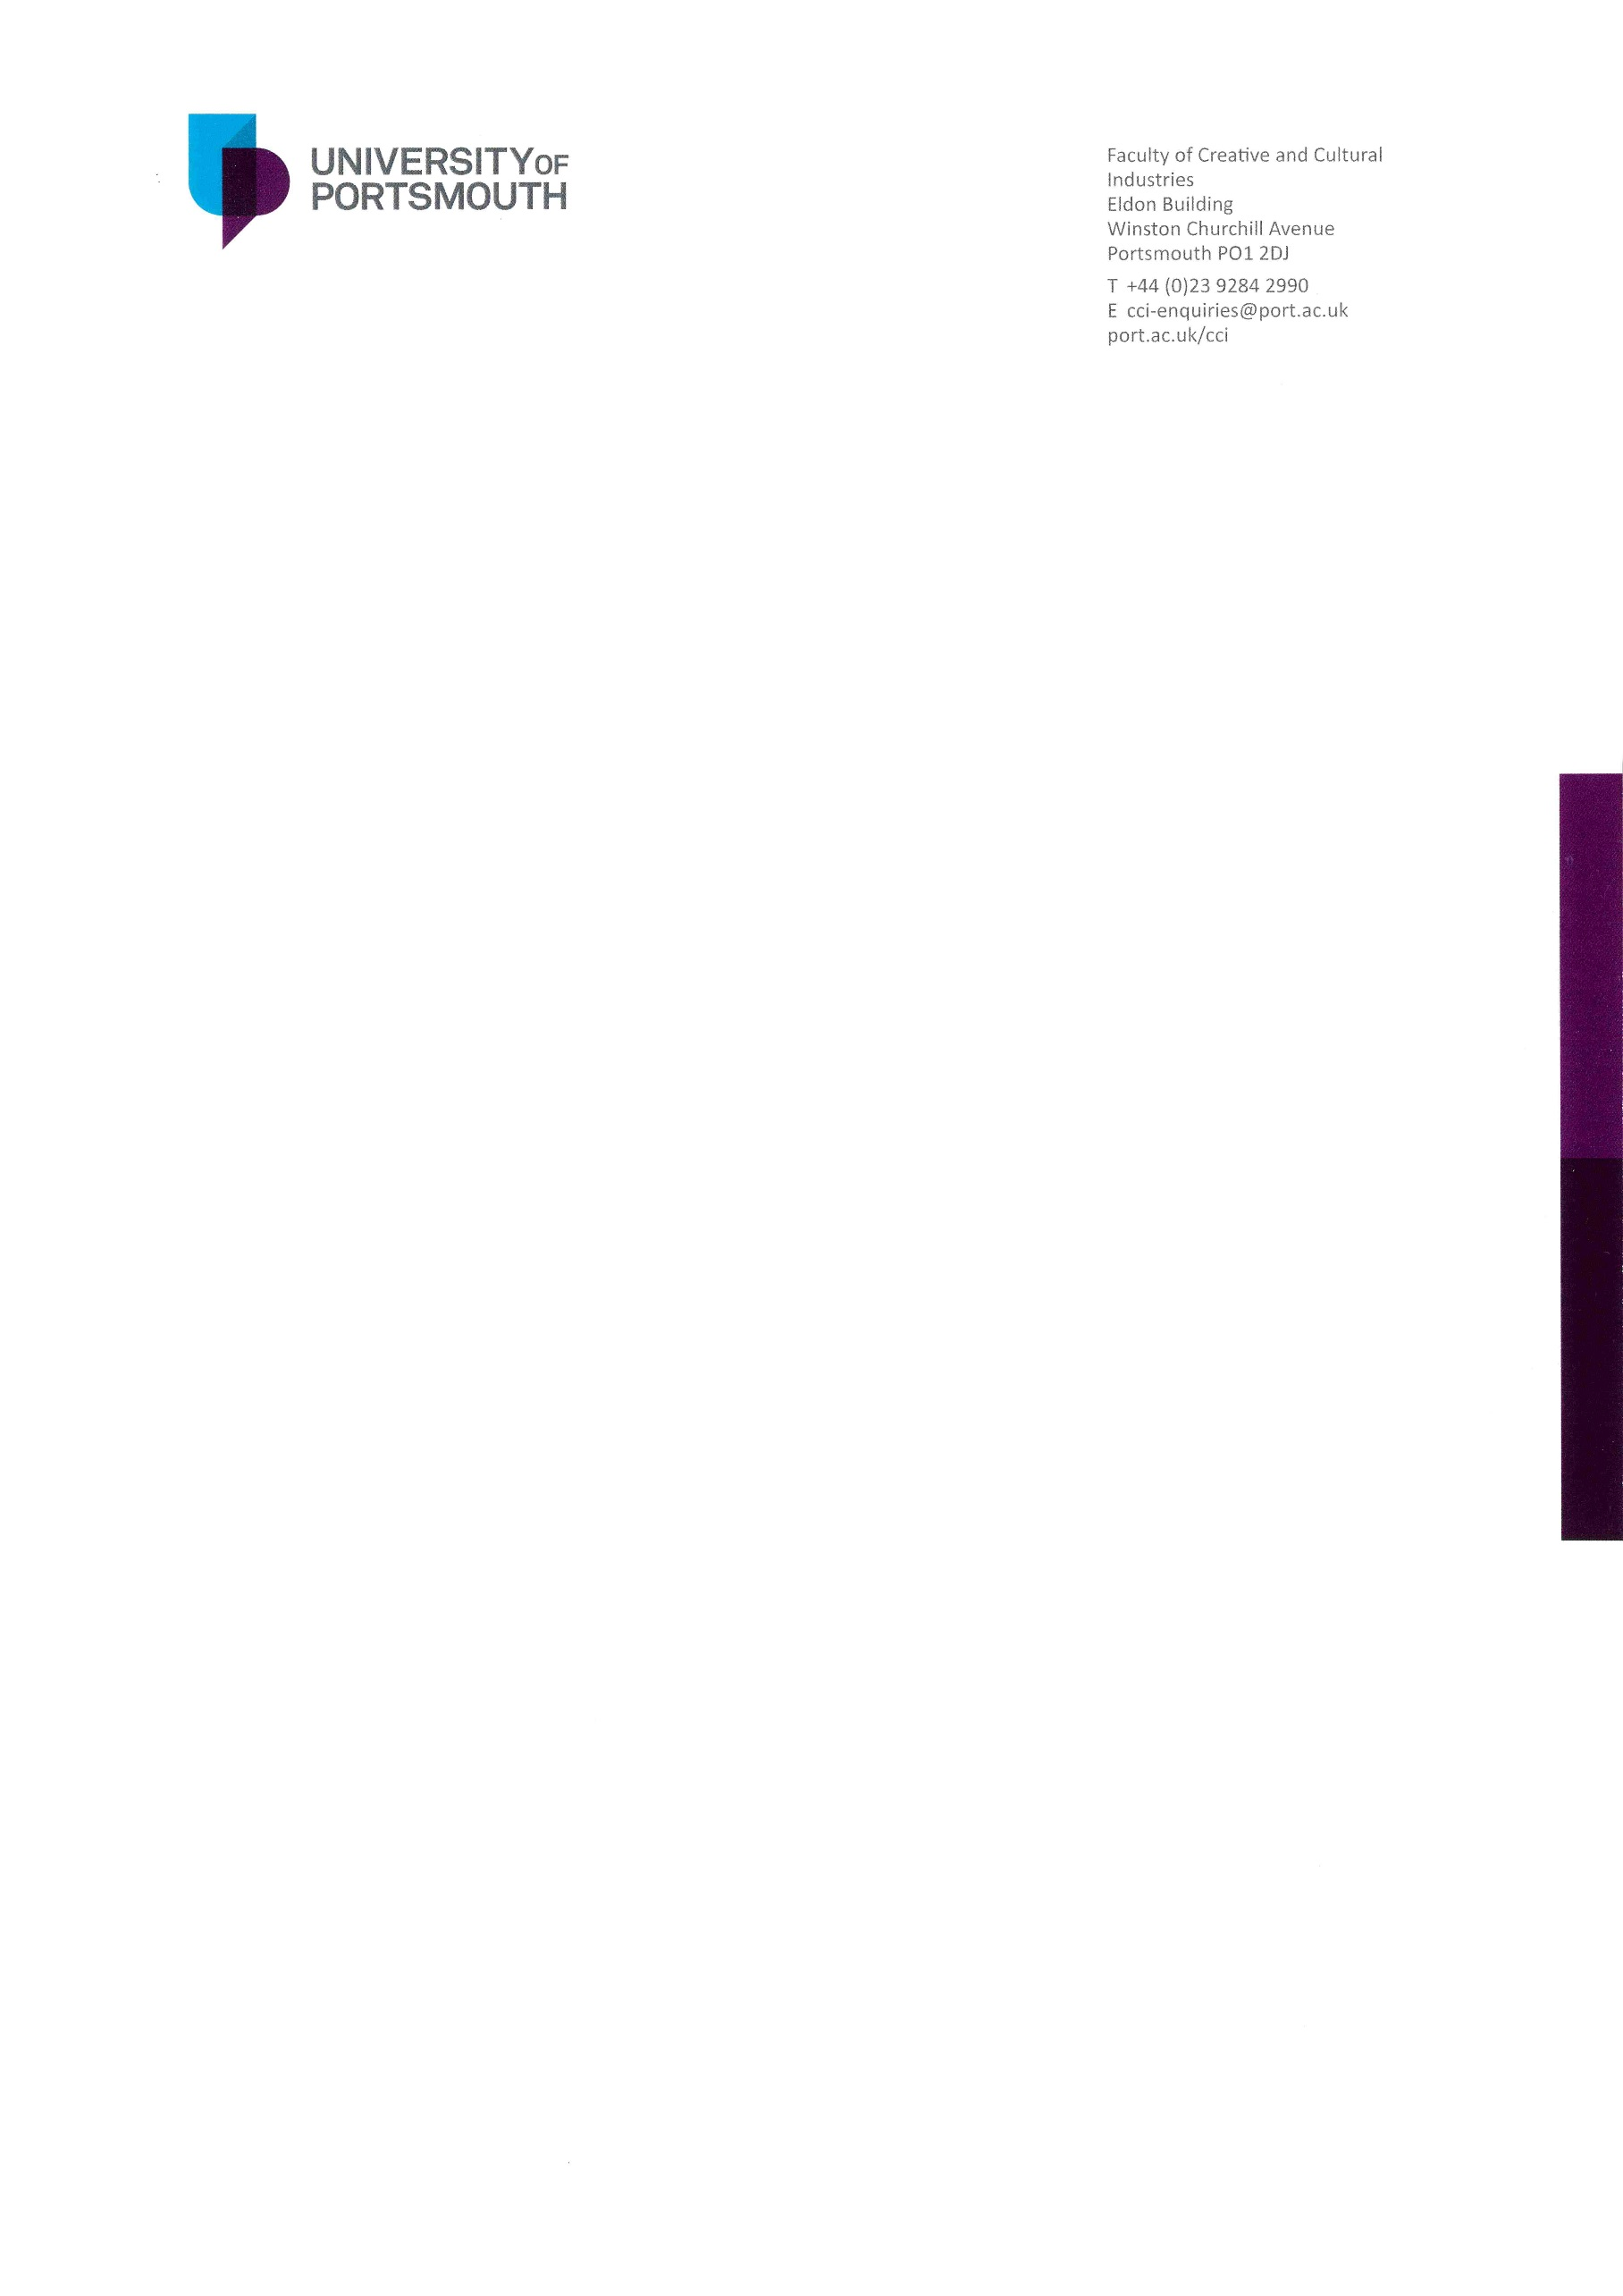

Thank you for your interest in the position of Head of the School of Film, Media and Communication at the University of Portsmouth.

This is a unique opportunity, following a recent realignment of academic departments, to lead the development of a new School comprising a range of outstanding courses and activities. With a staffing complement of around 45 academics, and over 1100 students enrolled on full-time and part-time undergraduate and postgraduate (taught and research) degrees, the new Head will play a vital role in ensuring and enhancing the quality of the School’s educational provision, inspiring and supporting staff in their professional development, and further developing its strengths in research, innovation and global engagement.

We are looking for someone with the attributes, skills, experience, and vision to make a real contribution, not only to the School, but to the delivery of the University’s and Faculty’s strategic ambitions. Working closely with the Dean and other senior staff within the Faculty, the successful candidate will be someone with demonstrable management and leadership experience, academic credibility, and the ability to foster and sustain a productive and collegial working environment.

This is an exciting time to be joining a creative, ambitious and increasingly globally engaged academic community. I look forward to receiving your application. If you would like a confidential discussion, or have any questions about the role, please do get in touch.

Best wishes



Professor Trevor Keeble

Dean of the Faculty of Creative and Cultural Industries

[trevor.keeble@port.ac.uk](mailto:trevor.keeble@port.ac.uk)

+44 (0)2392 855453