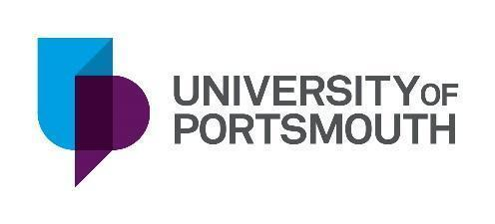 | Materials/Environmental Scientist – KTP Associate  Salary: 32.500 to 35,000 pa plus personal training budget  Employment type: Fixed-term contract for 36 months  Reference: ZZ008168  Closing Date: 26.02.2023  Interview Date: Week Commencing 6th March 2023  The University of Portsmouth, in collaboration with Fortis IBA Ltd is seeking an innovative and motivated graduate to lead and manage the development of sustainable higher-value precast concrete products using Incinerator Bottom Ash IBA) Aggregate.  The product will offer a more sustainable alternative to traditional precast concrete products, generating less carbon emissions and reducing the burden on the world’s natural resources, its production will also form a key part of the circular economy. The Associate will also establish new markets for the precast concrete products.  The Company  Fortis are leaders in processing IBA which is produced from energy-from-waste facilities from non-recyclable domestic waste.  Fortis recovers ferrous and non-ferrous metals from the IBA which are re-used worldwide to relieve the burden on mass extraction of low yielding virgin metal ores.  This process generates a resource called IBA Aggregate (marketed as Fortistone®) which is used as a sustainable alternative to primary aggregates within the construction industry to reduce reliance on natural resources.  IBA Aggregate has a key part to play in providing the building blocks for highways and construction projects as well as being part of the solution for the country’s waste.  For more information: https://fortisiba.com/  The Project  The objective of this KTP is to establish a circular economy for household waste by utilising incinerator bottom ash aggregate (IBAA) to produce sustainable zero-carbon cementitious products for the construction/housing industry.  You will be joining a friendly team based at the company in Portsmouth. In the role, you will be actively supported by knowledge transfer specialists with expertise in material sciences and environmental monitoring at the University of Portsmouth.  The Role  This is an exciting opportunity open to a candidate with a masters or Ph.D. qualification in Civil/Environmental Engineering or Environmental Sciences, or other related areas.  The post will provide the individual with an opportunity to make a significant contribution to the company’s innovation policy.  The successful applicant will be highly motivated and able to demonstrate some previous successful experience in a relevant role.  How to Apply  For an application form, full job description and further details please visit https://port.engageats.co.uk/. Potential candidates are invited to contact Dr. Muhammad Ali
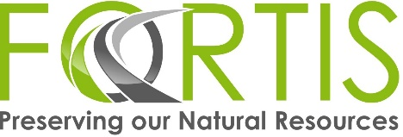
What is KTP?
Knowledge Transfer Partnerships (KTP), a government-funded scheme, brings together universities and businesses to work together on a development project that is strategically important to an organisation's future.

How does it work?
KTP Associate employed by the University and works full time with a company to deliver the objectives of a highly innovative development project.

What can KTP offer:

- £6,000 training budget
- Attendance at 2 one week management residential workshops
- Acceleration for your career
- A competitive salary
- The opportunity to lead and manage a highly innovative and strategic project
- The support of an academic team from the University
- The possibility of a permanent post with the company
- The possibility of working towards a higher degree

