Professor of Civil Engineering Science

Further Particulars

http://www.port.ac.uk/school-of-civil-engineering-and-surveying

Contents

Further particulars 2

Facilities 3

Research in civil engineering and surveying 4

Environmental technology and management 4

Further particulars
The School of Civil Engineering and Surveying (SCES) at the University of Portsmouth comprises 36 members of academic staff, over 600 undergraduate students, over 130 taught postgraduate students and 36 postgraduate research students. We deliver professionally accredited undergraduate and postgraduate courses. We also offer continuing professional development events for surveyors and other property professionals.
We pride ourselves on providing a friendly and supportive environment and the excellent relationship we have with our students is confirmed by consistently high rankings in the National Students' Survey. Our solid relationships with the construction industry mean our courses are designed with today’s global marketplace in mind. We provide our graduates with up-to-date technical and transferable skills appropriate to their field.
Our long-established network of consulting and contracting organisations provide real-world case studies, curriculum advice and feedback as well as excellent employment opportunities. Recent projects have involved collaborations with Astra Zeneca, BAE Systems, the Ministry of Defence, Mayer Brown Ltd and Grundon Waste Management
Most of our taught courses are accredited by professional bodies and include:
BSc (Hons) Building Surveying
Chartered Surveying Degree Apprenticeships
Property Development
Quantity Surveying
BEng (Hons) Civil Engineering
Construction Engineering Management
MEng Civil Engineering
MSc Building Information Management
Civil Engineering
Civil Engineering with Environmental Engineering
Civil Engineering with Geotechnical Engineering
Civil Engineering with Structural Engineering
Construction Project Management
Real Estate Management
Quantity Surveying

Facilities
Our laboratories for materials and structures testing, fluid flow modelling and geotechnical investigation include an offsite environmental laboratory located at a real sewage treatment facility. We also have an extensive network of computers, specialist software; specific facilities include:
Concrete lab
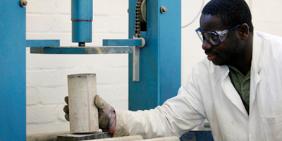
Our concrete laboratory is used by undergraduate and postgraduate students and researchers to produce and test concrete specimens. Teaching activities in the concrete lab include mixing and testing of concrete mixes designed by students to meet requirements set by the lecturer. All stages of the process can be observed and recorded on a newly installed camera system, which streams live video to a screen in the lab.

Environmental science lab
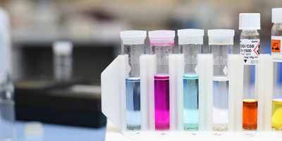
This laboratory holds all of the typical analytical equipment required for executing simple water tests, such as biochemical oxygen demand, chemical oxygen demand, suspended solids, nutrient analysis, pH and conductivity. We also have facilities for preparing soil and water samples for analysis and for analysing hydrocarbon pollution.

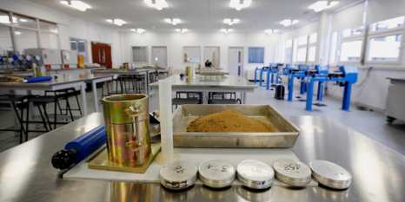
Geotechnics lab
The geotechnics laboratory equipment is used to fully characterise fine and coarse grained soils. It is equipped with a suite of fully automated testing equipment which is used for both undergraduate and post graduate teaching and research. There is also a dedicated 60 seater interactive tutorial area.

Hydraulics lab
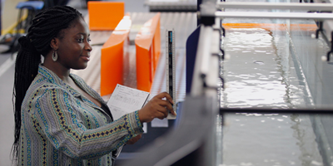
Our hydraulics facilities enable students to investigate all aspects of open channel flow such as flow over weirs and hydraulic jumps using a 300mm wide, 7 metre long tilting channel. There are also a number of smaller mobile hydraulics benches that can be used for experiments including pipe friction, fitting losses, flow in a venturi and impact of a water jet. In addition, flow nets can be modelled in soils by means of a drainage/seepage flow rate experimental set. Wave action can be simulated by means of an advanced wave generating device, and sediment transport can also be measured in situ.

Structures lab
Structures facilities include a range of modern model structures which are used in teaching to demonstrate the principles of structural engineering.

Environmental Technology Field Station
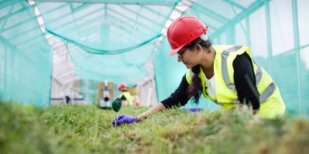
The Environmental Technology Field Station (ETFS) is a multidisciplinary research and teaching facility for environmental engineering and construction located near Petersfield, Hampshire, operated by SCES. The primary aim of the ETFS is to provide a research station for university and industry collaboration in a real-world, operational context delivered by the provision of expert consultation, environmental monitoring, laboratory analysis and the training offered to water industry staff. The ETFS also supports the multidisciplinary teaching activities of SCES and other departments at the University, including the School of Biological Sciences and the School of Earth and Environmental Sciences.

Research in civil engineering and surveying
Staff in SCES have a broad range of research interests ranging from structural analysis through to sustainability appraisal. Much of this work directly addresses real world problems, and the school has been very successful in securing funding to support this work from a range of sources including research councils, Innovate UK and industrial partners. Research is organised through three groups.

Environmental technology and management
The School has long been recognised for research in environmental technology and management. This work has been characterised by multi-disciplinary studies involving collaboration with other Departments (including Biological Sciences, Geography, Architecture and Pharmacy and Biomedical Sciences) as these interfaces often provide the most exciting areas of research.
The multi-disciplinary Environmental Technology and Management Research Group includes engineers, microbiologists and chemists. It was one of the pioneers in establishing Constructed Wetlands - a viable treatment technology for use in the UK and overseas. The interest in the use of ecological systems for environmental remediation has extended to the study of sustainable drainage and phytoremediation. The Group also investigates wastewater issues such as fats, oil and grease in sewers and the fate of pollutants. The scope of the work has extended into other areas such as rain water harvesting and sediment dynamics as new staff have joined SCES.
http://www.port.ac.uk/school-of-civil-engineering-and-surveying/research/environmental-technology-and-management/

Materials, structures and geotechnics
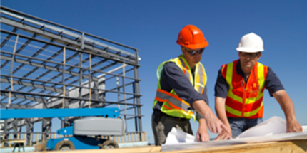
The Materials, Structures and Geotechnics Research Group comprises an active group of staff and research students considering a range of novel issues related to advanced civil engineering science. Materials research has a focus on fibre composites in engineering structures. This covers enhancement of traditional building materials, such as ultra-high performance concrete with steel fibres, and development of novel materials and components, such as fibre composite panel and flooring systems. The Group has a well-developed numerical modelling capability, with on-going work considering damage mechanics and crack propagation in these composite materials. Recently this has been extended to considering enhancement of traditional soil block technology by inclusion of agricultural waste fibres.
Structural monitoring has also been a long running research theme with current studies on the integrity of aging harbour jetties using high resolution photography. A recent project monitoring and modelling the movement of the Mary Rose Tudor warship as the hull dries will also make a contribution to informing future preservation strategies for the ship.
There is further work in fire structural engineering which is establishing calibrated thermo-mechanical numerical simulation procedures and the geotechnics team are developing a capability in the use of transparent soils to examine structure/ground interactions. Multidisciplinary projects are also in development to integrate Life Cycle Analysis and other sustainability tools to assess the use of recycled materials in various applications.
http://www.port.ac.uk/school-of-civil-engineering-and-surveying/research/materials-structures-and-geotechnics/

Construction Management and Surveying
Research interests in the Construction Management and Surveying Research Group cover four areas: the application of computer systems in construction; contemporary challenges of sustainability and regeneration; the integration of design and construction processes; and quantity surveying and construction law.
The group has a keen interest in the use of computer technology (software and hardware) to provide effective tools to help in the better integration of, and collaboration between, the various parties involved in the construction process. Some of specific interests include: building information modelling, building performance, the development of computer applications to solve everyday construction and engineering problems; the use of mobile devices on construction sites; and the integration of radio frequency identification on construction projects.
http://www.port.ac.uk/school-of-civil-engineering-and-surveying/research/construction-management-and-surveying/
Contact Us
School of Civil Engineering and Surveying,
Portland Building
Portland Street
Portsmouth
PO1 3AH

Queries about the post should be directed to Professor Djamel Ait-Boudaoud, Dean of the Faculty of Technology (dab@port.ac.uk); For an informal discussion about the subject areas, please contact Dr Dominic Fox, Head of Civil Engineering and Surveying (dominic.fox@port.ac.uk).

